# **Discussion**

# Overview

The swimming club “Lisburn Leisureplex” teaches children to learn how to swim. **It consists of:**

* A pool of size **13m x 14m.** Divided into 4-5 lanes (depending on the lesson plans)
* **Timeslots** for Lessons each day for **3-hours** with each lesson lasting **30mins.**
* Each class contains **1 *Level 2 Teacher***, **1 *Level 1 Assistant***, and between **6-8 children.**
* There is a Manager that oversees the classes and provides a SOW (Scheme Of Work).

**The current system** has each **Level 2 Teacher taking the register** **in a book** for each of their classes for the day and the **Level 1 Teacher preparing the equipment** for the lesson ahead and theManager gives the Scheme of Work (**SOW**) to the Teachers through a **sheet of paper.** After each week of Lessons, they **write up** **all the data of the registries onto pieces of paper**. They give each student a **score** which determines whether they **Pass or Stay** every term which consists of **3 months**.

# Problem

This method is very tedious, and a new more efficient way has been requested by the club. Currently they are running out of space to store their records of classes physically. As well as this, the pages tend to get worn by the water, so they wish to try a digital approach. With their current file system, it is easier to become disorganised as everything needs to be accessed manually.

# Objective

Create a system that allows the **Manager** to **post the SOW to all Teachers** so they can **easily and safely access** it throughout lessons. **Level 2 Teachers** can know **which class** they have next and **what level**. The **Manager** should also be able to **assign** Level 2 Teachers their own **Level 1 Assistant** for the day as well as **what equipment** is required. The **register system** should be available for all **Level 2 Teachers** and **Manager**. Level 2 Teachers can **write notes about swimmers** and have information about any **SEND (Special Educational Needs and Disabilities)** and other relevant information.

# Stakeholders:

* Managers – want to access any swimmer or teacher information.
* Level 2 Teachers – want to view SOW, register system, and current class/level.
* Level 1 Assistants – which equipment to gather, for which Teacher.

# Scope

**Managers** will be able to login using **Username** and **Password**. They will be able to **view/edit all notes and progress** for classes, swimmers **current scores, SEND** and whether they **Pass or Stay**. They can **organise classes** and **post the SOW** for Teachers in a set location. Have access to **Teacher's information** i.e., email, role etc. Access to **Register system.**

**Level 2 Teachers** can login with **Username and Password.** They can **write/view notes for their classes** and any **SEND.** View swimmers **notes and scores** as well as being able to **edit** them. View **SOW/details of lesson** for their class as well as their **current class and upcoming classes**.

**Level 1 Assistants** can login with **Username and Password. View** classes/teachers as well as **upcoming** classes/teachers. Their **role in class.** Access to **view** swimmers’ **notes and SEND.** View the **SOW/details of lesson.**

# Limitations:

* Time – as the club needs a working Lesson Manager ASAP
* Storing data – all data previously stored by the club will take a long time to process.
* Complexities/functionalities of the system may not be fully implemented.

# Entity Relationship Diagram

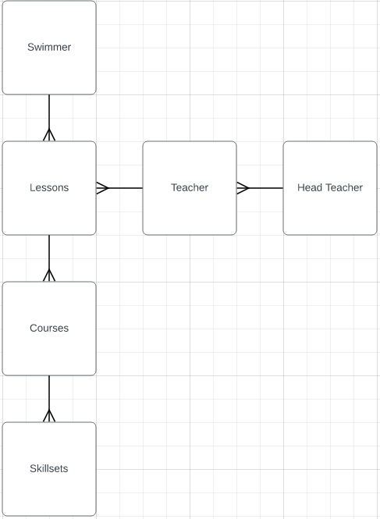

# Feedback

|  |  |  |
| --- | --- | --- |
| Suggestion | Accepted/Rejected | Justification |
| An email system to inform parents of the performance of their child. | **Accepted** | It's within the parent’s right to know how their child is progressing every term. |
| A technician role which is specifically there for IT related admin, allowing the Manager to focus on notes and grades. | **Rejected** | The scope of the project does not have the time to work on this specific function as the club needs the Lesson Manager ASAP. |
| Making the Lesson Manager web-based for easier access | **Rejected** | The scope of the project does not require the system to be web-based, it just needs to be functional. |